Workshop 1 : How to quickly grow your Western business in the Chinese market
When: Thursday May 4th 2017
Time: 11:00-11:45 AM
Where: Innovation Pavilion

The Chinese environmental technology sector comes with its own unique set of challenges, which require a tailored approach and mind-set. Join our workshop and learn more about how to quickly grow your business in this market. Topics covered will include:
- Finding the right local partners
- Managing distributors and sales organisations
- Relations with (local) governments
- Localised production and product development
- IP concerns and legal issues
During the workshop there is ample time for questions and discussion, so we encourage you to bring your company’s challenges and questions to the attention of the expert.
Speaker Gijsbert de Bruin – CEO of CHC Group
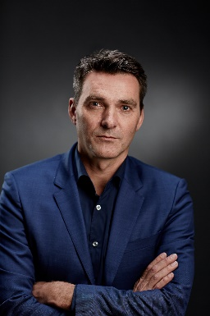
Gijsbert is the CEO of the CHC Group, which has been active in China since 1998. During this period he has expanded the group with numerous new companies which are exceptionally successful at selling to the local Chinese market. He is an expert at managing distribution networks, selecting the right partner and Chinese business practices. As an entrepreneur Gijsbert has dealt with a vast array of issues facing Western companies doing business in China and has an intimate knowledge of and network in the Chinese environmental technology sector. With Launch Factory 88 he invests in innovative environmental technology companies and actively helps them expand sales in the Chinese market. Gijsbert is a popular guest speaker at conferences on doing business in China and speaks fluent Mandarin.

